Project 1: Human Factors

Part 1:

Requirements in separate partOneReq.doc

Excel & User Case:

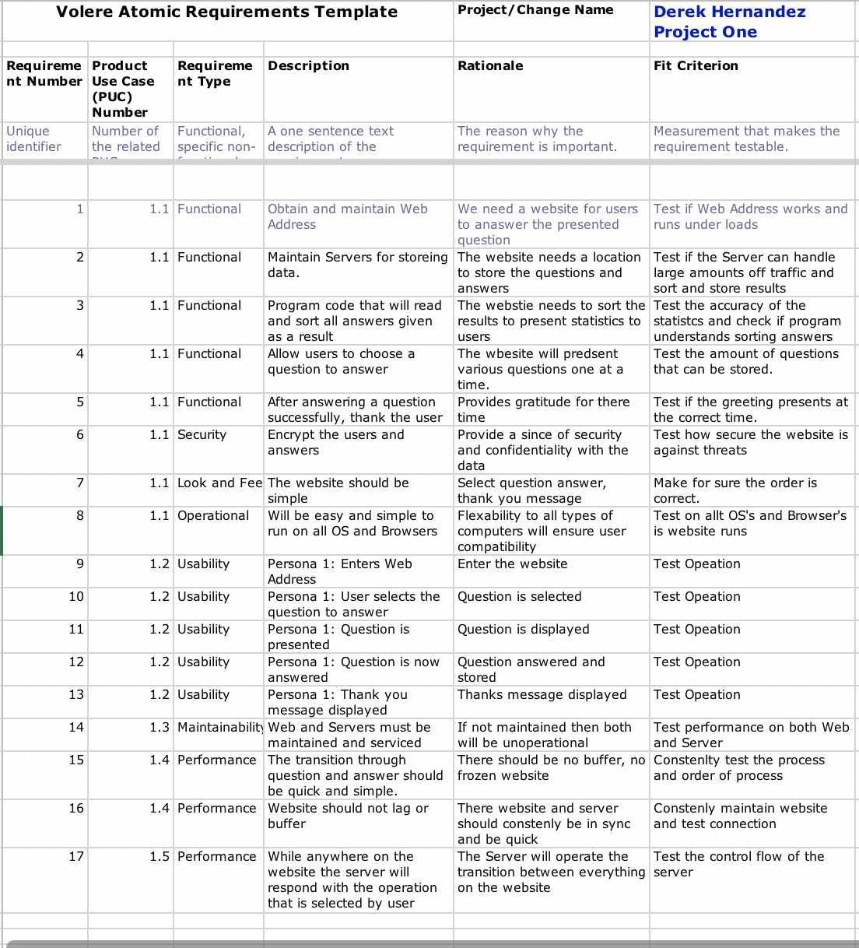

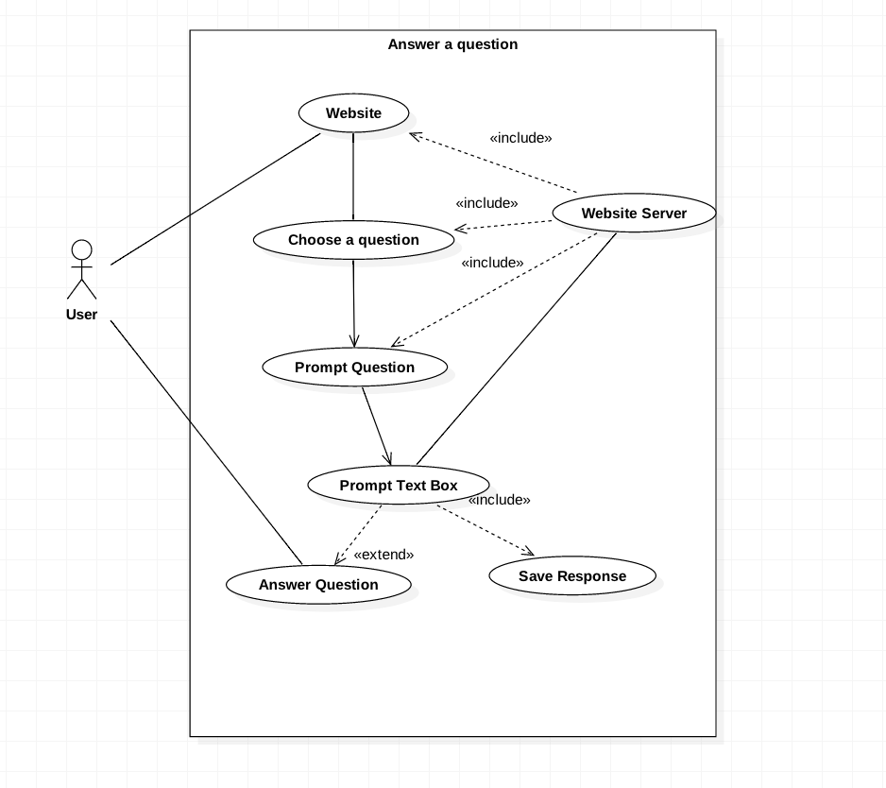

Part Two:

Conceptual design:

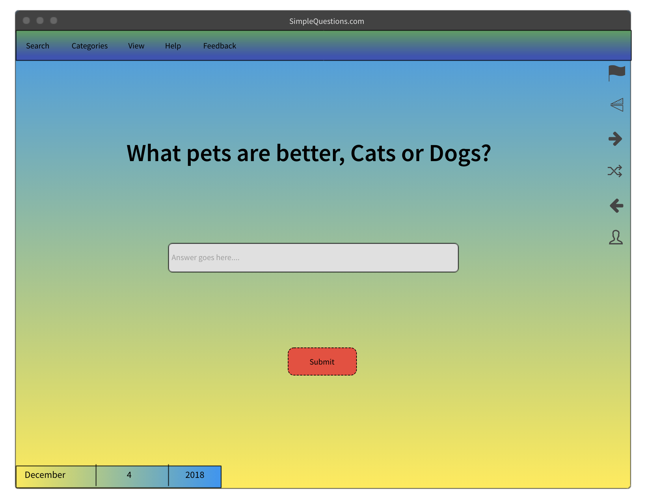

Snow cards: attacked in snowcards.doc